**How to Route a Document from the Exceptions Queue:**

1. Open ImageNow > Click Workflow
2. 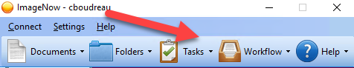
3. Go to Your Department’s Corresponding Queue
4. 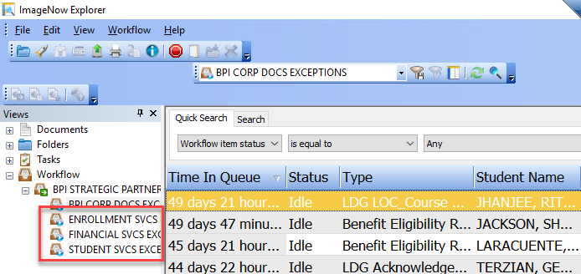
5. Double click on a line to open the document
6. Ensure Forms & Properties are shown (click F7 and F12 to toggle on/off)
7. Review Document Management & Imaging (DMI)’s notes and provide missing information by adding a new Comment
8. 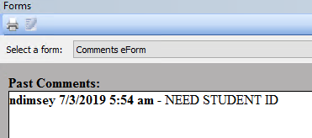
9. 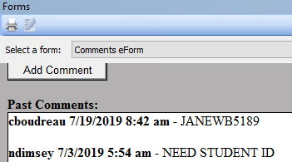
10. Type “LINK” in Notes table
11. 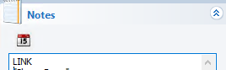
12. Click Route Forward icon
13. C:\Users\CBOUDR~1\AppData\Local\Temp\SNAGHTML905219d7.PNG

**Best Practices & Tips**

* Before resubmitting a document to [corporate.documents@bpiedu.com](mailto:corporate.documents@bpiedu.com) > Check the Exceptions Queue, add identifier(s), and route from there to avoid duplicates in CampusVue
* Check in CampusVue to see if document in Exceptions Queue is already on file/approved > then add “DELETE” in Notes pane (do not route forward, DRCs to delete)
* Use Transfer Credits Hot Keys in Cvue to grab the Student ID faster! (Alt – V-R-N > Ctrl C to copy it).
* If you are trying to locate a CFTG/BHTG student with a common name, use Advanced search to narrow down results

